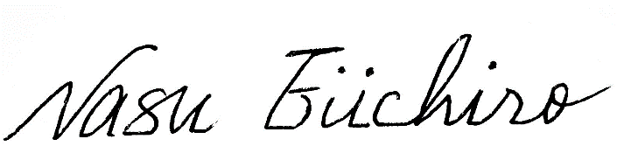

***of Junior High School has***

***achieved excellent results in the 55th English***

***Word Contest of the Junior High Schools of***

***Miyazaki Prefecture. 2017***

***President of the Society of English***

***Teachers of Junior High Schools of***

***Miyazaki Prefecture***

***This is to certify that***

**HONOR**

**CERTIFICATE**