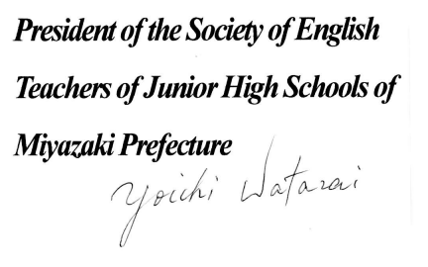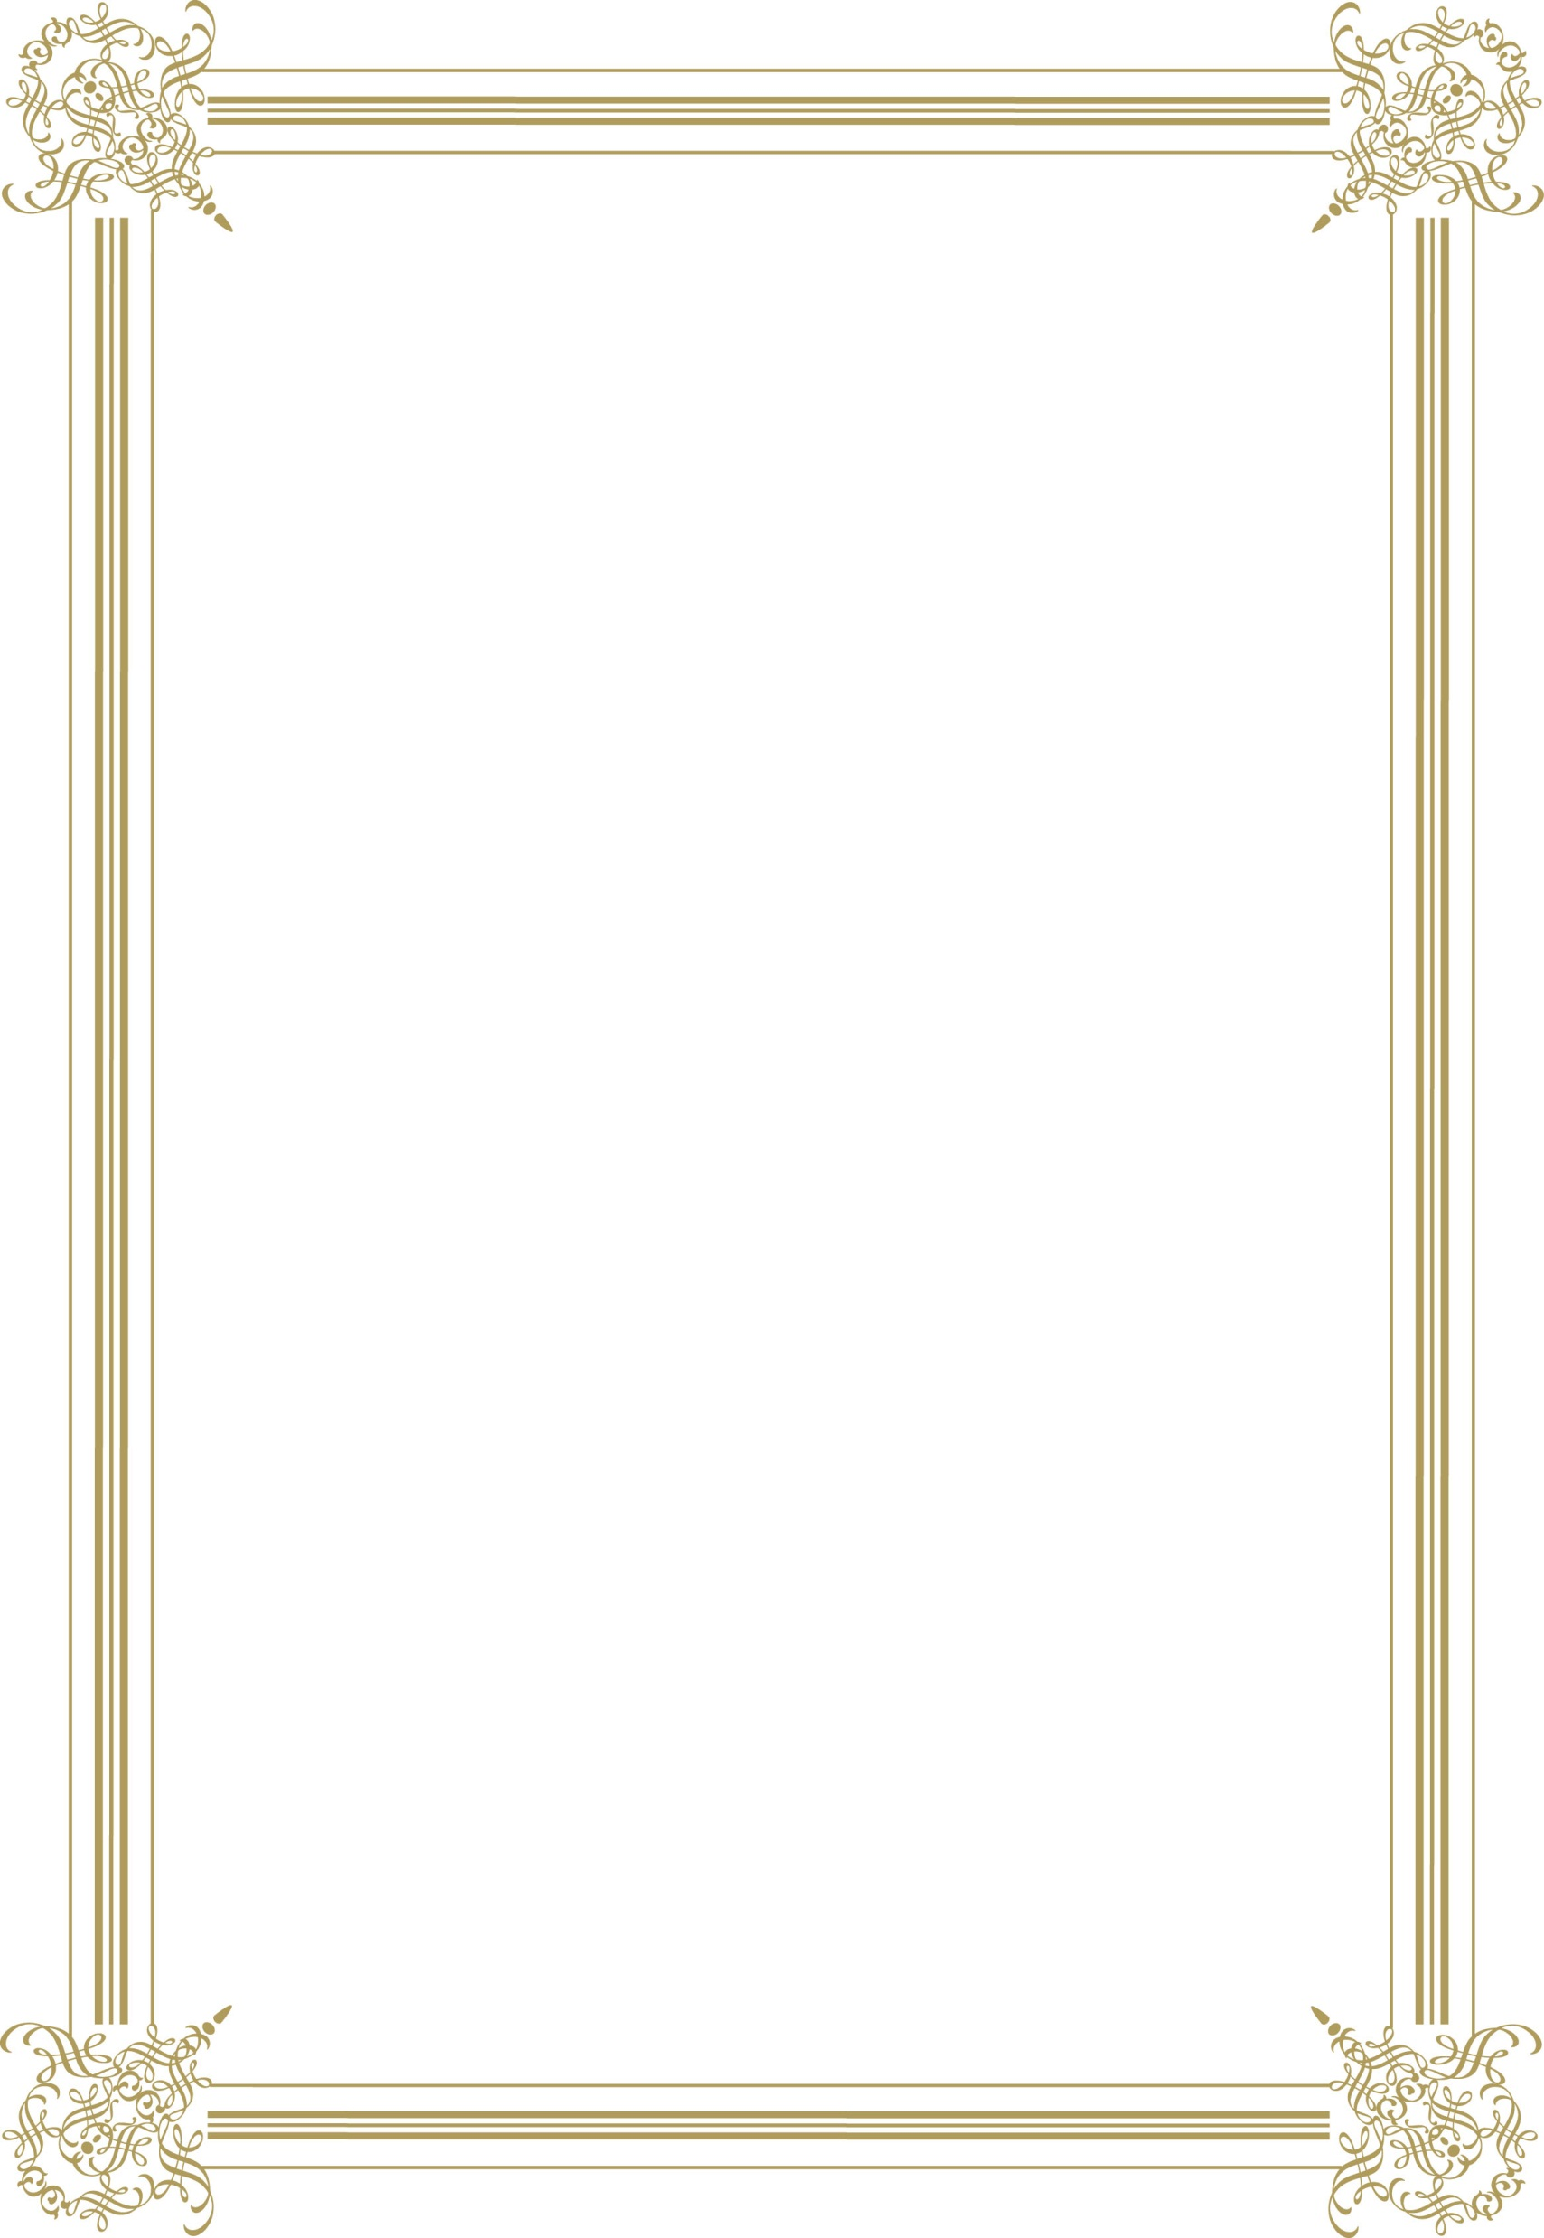

***of Junior High School has achieved excellent results in the 60th English Word Contest of the Junior High Schools of Miyazaki Prefecture. 　　　　　 2022***

**HONOR**

**CERTIFICATE**